HeadWay

Customer：

Product name： Cylindrical lithium-ion Iron Phosphate battery

Model No.： HW 40152S

Specifications： 15000mAh/3.2V

Add.： Tai Hu Road, Changxing Eco.&Tech. Development Zone, Changxing County, Zhejiang Province, China

Designed | Approved | Inspected
Si Fanghong | Xu Aokui | Li Xingli

1st, May. 2003 Published 20th, Oct, 2003 Completed

- Range of application:
This specifications is applied to Headway lifepo4 batteries produced by Zhejiang Xinghai Energy Technology Co.,Ltd.

- Product name and models:
  - Name: Headway cylindrical lifepo4 battery
  - Model: HW 40152S
- specifications:
NO. | ITEM |  | Specifications
3-1 | Nominal Capacity: |  | 15000mAh
3-2 | Rated voltage |  | 3.2V
3-3 | Energy density (Wh/kg) |  | 100
3-4 | Internal Resistance |  | ≤4mΩ
3-5 | Charge (CC-CV) |  | Charged with constant current to 3.65v and then charged with constant voltage to 0.1-0.2A
3-6 | Charge (float) |  | ≤3.6V
3-7 | Max. charging current |  | 3C
3-8 | Standard. charging voltage |  | 3.65±0.05V
3-9 | Recommended charging current |  | 0.5C
3-10 | Max. continuous discharging current |  | 5C
3-11 | Max.pulse discharging current(30seconds) |  | 10C（150A）
 | Recommended discharging current |  | 1C(15A)
3-12 | Max. End-off discharged voltage |  | 2.0V
3-13 | Self discharge rate (monthly) |  | 2-3%
3-14 | Dimensions (mm) | Diameter | 40±1
3-14 | Dimensions (mm) | Height | 165.5±0.5
3-15 | Weight (Approx.) |  | 480g
3-16 | Working temperature | Charging | 0~45℃
3-16 | Working temperature | Discharging | -20~65℃
3-17 | Storage  temperature | In one month | -20~45℃
3-17 | Storage  temperature | In six months | -20~35℃

*The battery shall be in the state of half –fully charged or with the voltage of 3.2~3.3V during storage and transportations.

3-18 The dimensions drawing:

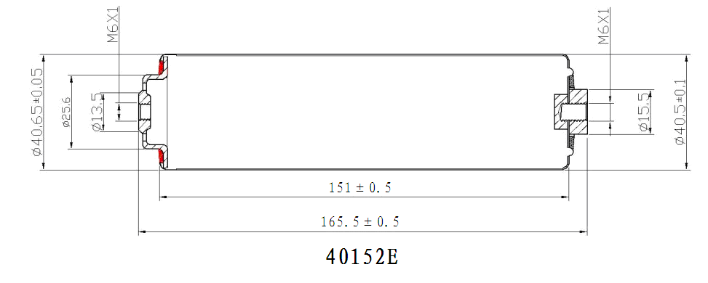

40152S discharging curves at different temperature:

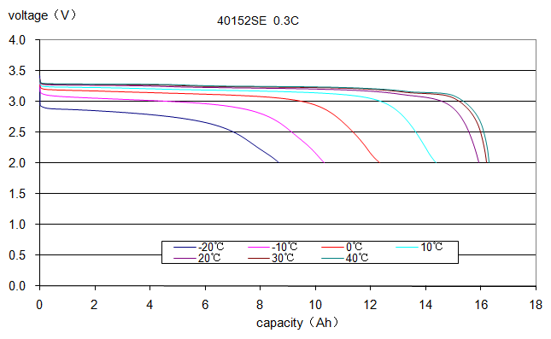

40152S discharging and charging curvs at 0.5C:
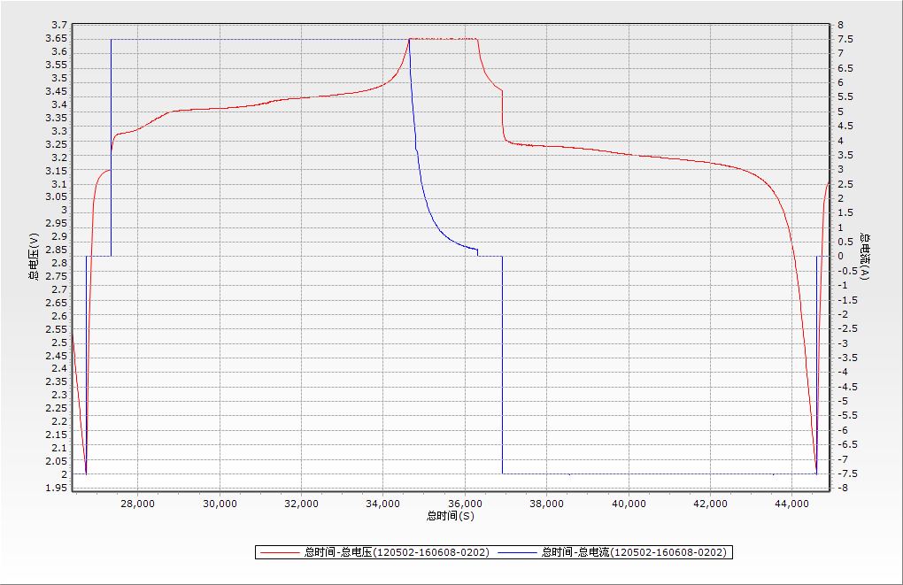

40152S discharging and charging curvs at discharging rate of 1C:

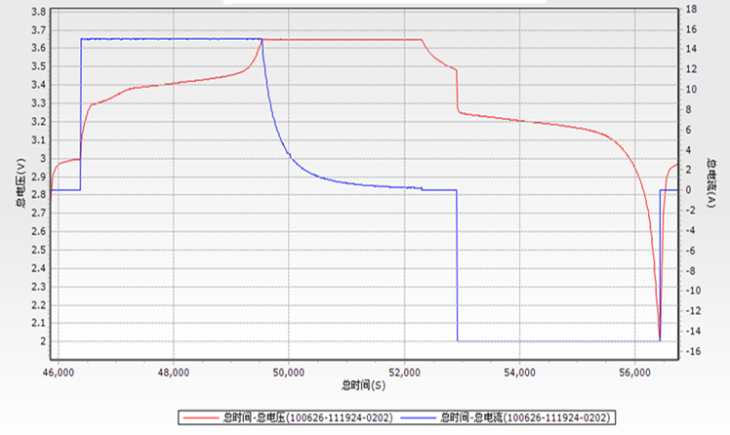

40152S discharging and charging curvs at discharging rate of 5C:
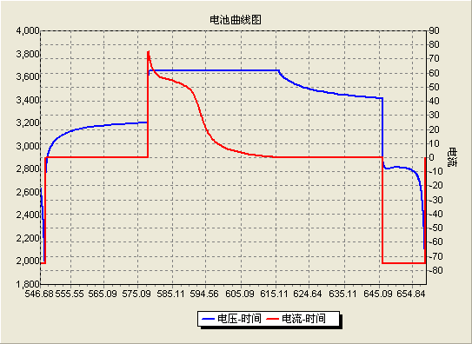

40152S cycle life vs DOD:

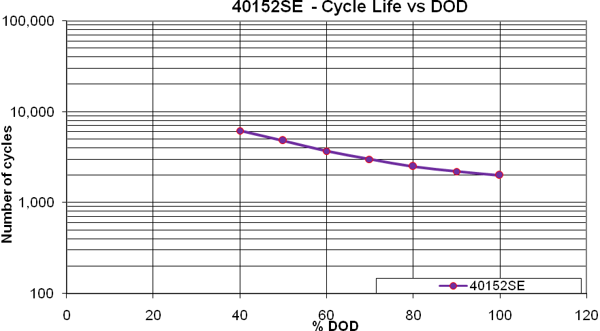

40152S cycle life at 1C:
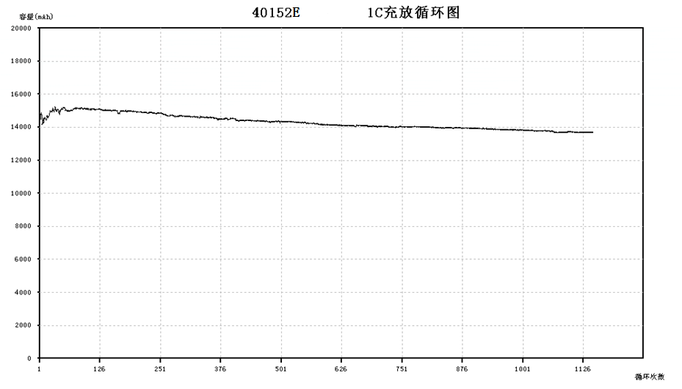

4.Test conditions
4.1 The experiments and survey should be on the nominal temperature of 20±5℃, and
the nominal humidity should be 65±20%.
Standard charging: first charged by constant current of 0.5C, then by contant voltage up to 3.65v, and when the current falls down to 300mA, then stop the charging.
Standard discharging: discharging at constant current of 7500mA until the voltage falls down to 2.0V.
4.2 The testing facilities:
Voltmeter: Impedance ＞1000Ω/piece;
Ammeter Total resistance ＜0.01Ω;
Vernier Caliper: Precision: 0.02mm;
5. Testings
5.1 Appearance
The surface should be clean, no mechanical damage, adherent point should be no rust, and there should be necessary marks on the cells.
5.2 Characterisitcs
Item | Test program | Standard
5.2.1Open-circuit voltage | After standard charging ,then measure the open-circuit voltage in one hour. | ≥3.3V
5.2.2 Nominal capacity | Discharging by constant current of 0.5C in one hour until the voltage falls down to 2.0V | Capacity≥15Ah
5.2.3 Cycle life | At the temperature of 25±5℃, charged by constant current of 0.5C until the voltage comes up to 3.65V, then charged by constant voltage of 3.65v until the current falls down to≤ 300mA, then kept aside for 0.5-1hour, then discharged of 0.5C until the voltage falls down to 2.0V, then kept aside for another 0.5-1hour, then stepped into the next cycle. If the capacity falls down ≤12000mAh for two continuous cycles, then it is considered as dead | ≥2000times
5.2.4 Reserve ability of the capacity | After standard charging and storaged at 25±5℃ for 28days, then discharging at 0.5C to the voltage of 2.0V, the reserved capacity is ≥ 90% nominal capacity. | Capacity≥ 13.5Ah
5.2.5 High Temperature performances | After standard charging and storaged at 60±2℃ for 4 hours, then discharging at 0.5C to voltage of 2.0V, the reserved capacity is ≥ 90% nominal capacity. | Capacity≥ 13.5Ah
5.2.6 Low temperature performances | After standard charging and storage at -10±2℃ for 4 hours, then discharging at 0.5C to the voltage of 2.0V, the reserved capacity ≥ 60% nominal capacity. | Capacity≥9Ah
5.2.7 Extrusion | Put the battery into the two planes of the extrusion equipment, boost pressure to 13KN, keep the pressure for 1 min. the vertical axis should parallels to the horizontal plane of the extrusion equipment, be vertical to the direction of extrusion, each battery only accept one test. | The battery must be no fire and no explosion.
5.2.8 Thermal shock | After putting the battery into the incubator, the temperature should be increased continuously at the rate of 5℃±2℃/min to 130℃and kept for 30 min, then take out the battery, resume to the room temperature. | The battery must be no fire, no explosion.
5.2.9Overcharged | The test is made at temperature of 20℃±5℃. The battery should be discharged at I₅A until the voltage is 2.0V, put the battery into ventilation cabinet, connecting the anode and cathode to the DC power supply. Change the output current of power supply to 15I₅A, The voltage should not be lower than 10V, charging for 7 h or and the voltage stays the same, until the current falls down to 0. | The battery must be no fire and no explosion
5.2.10Forced discharge | The test is made at temperature of 20℃±5℃. Discharged at I₅A until the voltage falls down to 2.0V, then reverse charged at 5I₅A current for 90 min. | The battery must be no fire and no explosion.
5.2.11 Short circuit | After standard charging fully, put a battery which is connected with thermocouple (The essential resistance of the circuit should be less than 50mΩ ), short circuit for the anode and cathode,monitoring the temperature of the battery, when the battery temperature falls with a range of 10℃, then stop the testing. | The battery must be no fire and no explosion.
5.2.12 Acupuncture | The test is required to operating at the temperature of 20℃±5℃. Standard charged to the voltage of 3.65V, Put the battery in which is connected with thermocouple into the ventilation cabinet, pricked with a diameter-3mm stainless steel pricker throughout the centre of the of the battery at most surface in 20mm/s~40mm/s speed, and keep 1min. | The battery must be no fire and no explosion.
5.2.13 Heavy Impact | Put the battery on the floor, put a Φ15.8mm Steel column into center of the battery, the vertical axis of the Steel column should be parallel to the floor, then let the 9.1kg’s heavy object fall on to the steel column from a height of 610mm. | The battery must be no fire and no explosion.
5.2.14 Vibaration | After standard charging fully, put the battery on the vibaration table of vibarating frequency of 10Hz-30Hz, and continuously vibarated from X,Y,Z three directions with 10Hz-50Hz for 30mintues, and the speed is 1oct/min。 | There is no damage of the appearance and no smoking, no penetration, no explode, and the voltage is no less than 3.2V
5.2.15Collision | After vibaration testings, fix the battery from X,Y,Z three perpendicularity and colliding pulsely at 100m/s2，and 40~80times per min，and each pulse collisions keeps 16ms and 1000±10 times. | There is no damage of the appearance and no smoking, no penetration, no explode, and the voltage is no less than 3.2V
5.2.16 Free fall drop | After standard charging fully, let the battery fall from a height of1m from X,Y,Z six directions accordingly to the hard wood with thickness of 18-20mm on the cement floor, each for each direction, and then discharged at 1C until the voltage is 2V, then make they charging and discharging cycles no less than 3cycles. | No fire, no explode, and the discharging time is no less than 51minutes
5.2.17StorageCharacteristics | Battery shall be charged continuously at a constant current of 0.5C until the voltage is up to 3.65v, then charged at the constant voltage of 3.65v until the capacity falls down to 0.02c; and stored under the condition of normal temperature of 20℃±5℃ for 30days; After 30-days’storage, discharge the battery continuously at the constant current of 0.5C to the end-off voltage of 2.0V | Remaining capacity ≥ 13.5Ah

6. Matters need attention.
6.1 Don’t put the battery near the origin of heat, such as fire, heater etc.
6.2 Please use the matched charger to charge the battery.
6.3 Don’t convert the anode and cathode.
6.4 There are safety features in the battery, in order to keep safe, do not dissect or change the structure of the battery.
6.5 It is forbidden to connect the anode and cathode directly with metal.
6.6 It is forbidden to pound, throw , trample the batteries.
6.7 It is forbidden to put the battery into the water, or in the moisture place.
6.8 If the battery are storaged without being used for 6 months, we recommend the batteries fully charged before using them.
7.Shelf life
7.1 The shelf life is 24 months since the production time.
7.2 Our company is not responsible for quality inferiority or accidents caused by abuse operating or using which are not compliant with the specifications and instrutions.
8.Transportation
During the transportation, preventing the strenuous vibration, impact, exposed to the sun and rain, and keep the battery on a state of half-charged.

